ANIL BAINSLA
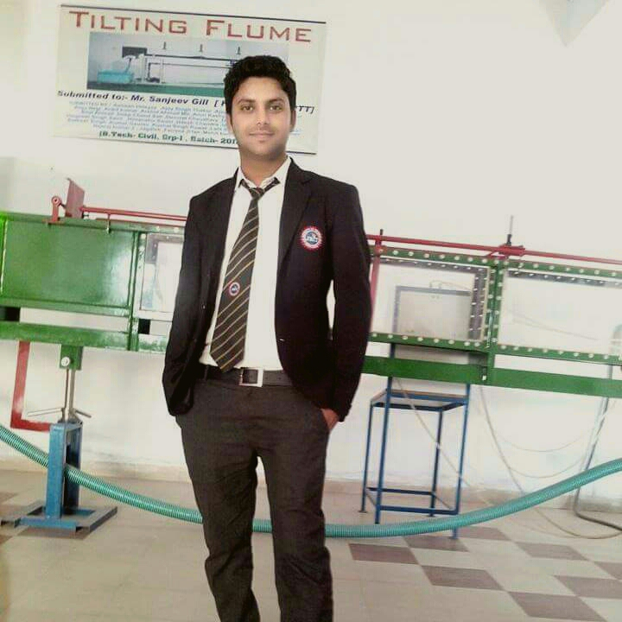
Vill-Ghasera Distt-Palwal,Haryana-INDIA
Contact Number: +91-9599042043
Email Id: anilengineer1989@gmail.com

SUMMARY
- Civil Engineering Graduated from JB Institute of Technology, Dehradun (AICTE Approved) affiliated from Uttarakhand Technical University (UTU), Dehradun.
- Attended Work Shop in Concrete Mix Design at JB Institute Of Technology, Dehradun Organized by “JP CEMENT”.
- Attended 6weeks Vocational INDUSTRIAL Training Program in “HIA ENGINEERS & CONTRACTORS, Haryana” (From July-August 2015) under the Project of Constructions of NH-2 road from Delhi to Agra.
- Result Oriented, Self Driven, Highly Motivated, Smart and Hungry to learn new Technologies, Methodologies, Strategies and Processes..
- Participated in Conference on Topic “EARTHQUAKE & ENVIRONMENT”

EDUCATIONAL DETAILS

- B.Tech in CIVIL ENGINEERING (2012-16) from JB Institute of Technology, (AICTE Approved) Dehradun with an aggregate of 68%.
- 10+2(2009) with Physics, Chemistry and Mathematics from Haryana. Board with 60.00% marks.
- High School (2006) from Haryana. Board with 72.66% marks.

TECHNICAL SKIL

MS-Office, Window 8,MS -Excel,Powerpoint,Word

Internet Ability.

PROJECT DETAIL

DESIGN AND DEVELOPMENT OF CABLE STAYED BRIDGE
  - Duration : 4 months (Aug -2015 to Nov-2015)
  - Team size: 5
  - Role played : Designer and Developer
  - Guide: Mr. Manish Kaira and Mr. Sanjeev Gill, Head of Department of Civil Engineering, JB Institute Of Technology – Dehradun.

STRENGTHS
- Good Oral, Written and Presentation Skills.
- Quick Learner with Good Grasping ability.
- Action Oriented and Result focused.
- Lead and Work as a Team in an organised way.

EXPERIENCE
- 9 months experience in “Om Sai Construction Pvt. Ltd” as a civil Engineer in maintenance work.

EXTRA CURRICULAR
- Participated in Surveying Task in SRIJAN Organized by “JB Institute of Technology- Dehradun” in 2015
2. Participated in Cultural Activities of the College and School.
3. Member of Event Organizing Committee of the College

HOBBIES
- Drawing, Painting, Listening Music, Playing cricket.
- Riding bikes and Travelling.

PERSONAL DETAILS
Date of Birth: 02.08.1990
Sex & Status: Male & Single
Nationality: Indian
Father’s Name: Mr. Lal Singh
Mother’s Name: Manoj Kumari
Address: Vill- Ghasera,P.O- Khambi,Teh- Hodal, Distt- Palwal, Haryana. Pin-121106
Languages known: Hindi and English

All testimonials will be produced at the time of interview.

Date: 04.12.2018

ANIL

